USER MANUAL
Intellima

Table of Contents
- Authentication & Authorization
- Users Overview
- Seller Functions
- Buyer Functions
- Bank Functions
- Breeder Functions
- Inventory Manager Functions
- Slaughter House Manager Functions
- Chilled Warehouse Functions
- Collateral Manager Functions
- Export Manager Functions

Authentication & Authorization

Users:
- Sellers
- Buyers
- Breeders
- Bank
- Slaughter House Manager
- Collateral Manager
- Inventory Manager
- Export Manager

Seller Functions

Registration and Login

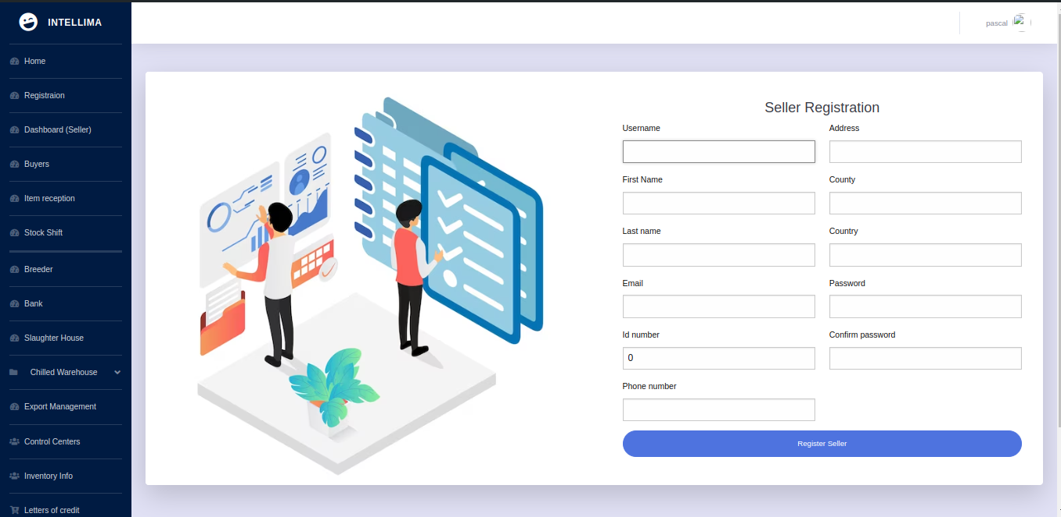
- System Administrator registers the Seller and Bank.

- Seller receives an email to set their password.

- Upon successful password setup, the Seller can log in to the system.

Dashboard Overview
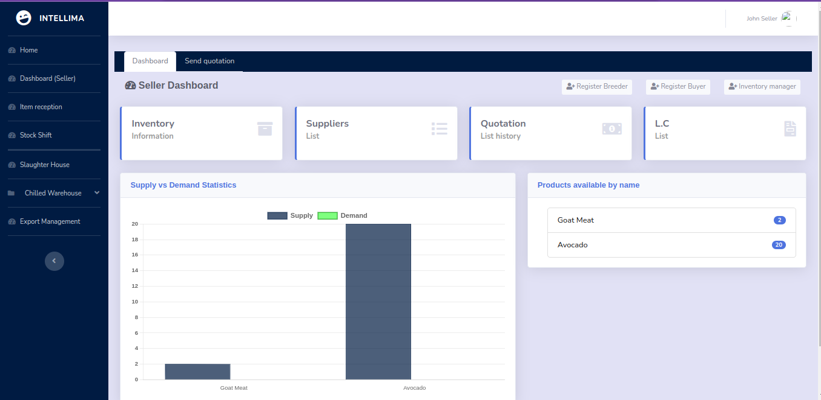
- Supply and Demand Statistics: Sellers can view these for decision-making.
- Letters of Credit and Quotations: Both approved and rejected.
- Item Supply History: Detailed records of past supplies.
- Inventory Items: View items with cumulative totals.
- Weight Comparison: Track item/breed tag numbers throughout the supply chain and compare weights.

Buyer Management
- Seller registers the Buyer.
- Buyer receives an email to set their password and logs in.
- Seller sends a quotation to the Buyer based on prior agreements.

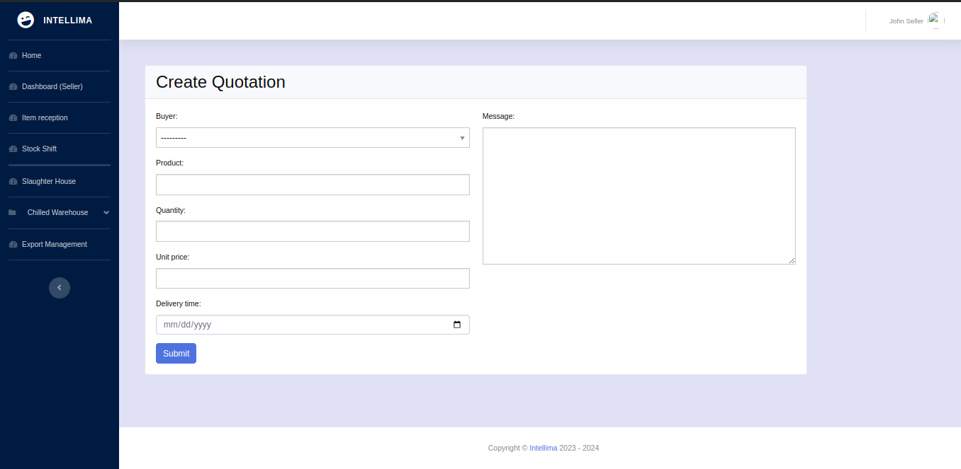

PDF documents for both Buyer and Seller are auto-generated.
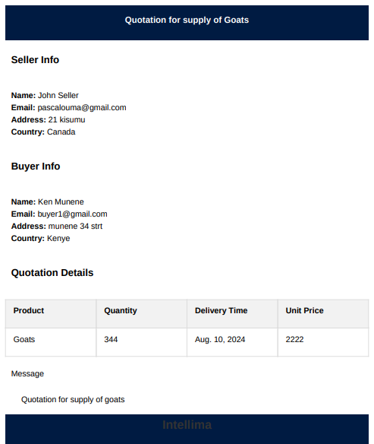

- Buyer receives an email with the new quotation and PDF.

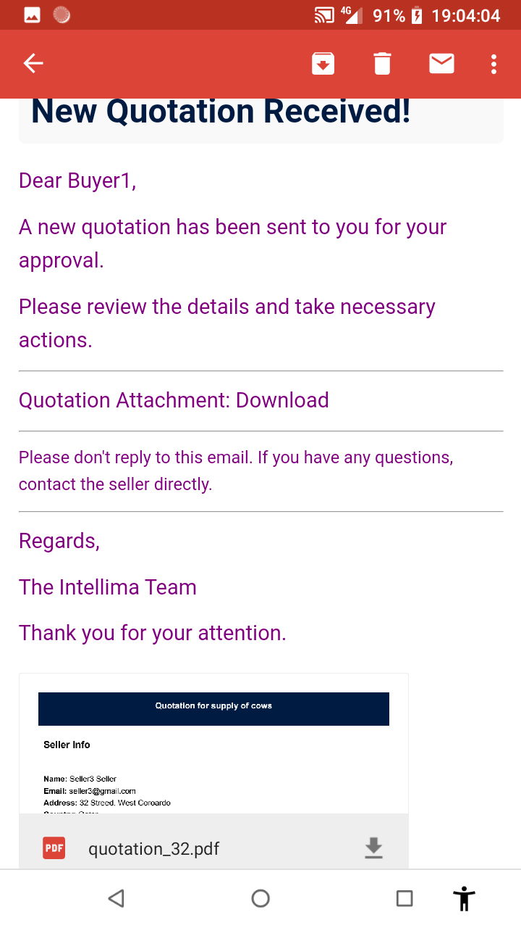
Buyer can accept or reject the quotation:
  - If rejected, they must provide a reason.
  - If accepted, the Buyer
  - communicates with their bank to send a Letter of Credit (LC) to the Seller's bank.

Letter of Credit (LC) Management

- Bank sets their password upon registration and logs in.
- Bank uploads the PDF received from the Buyer’s bank.

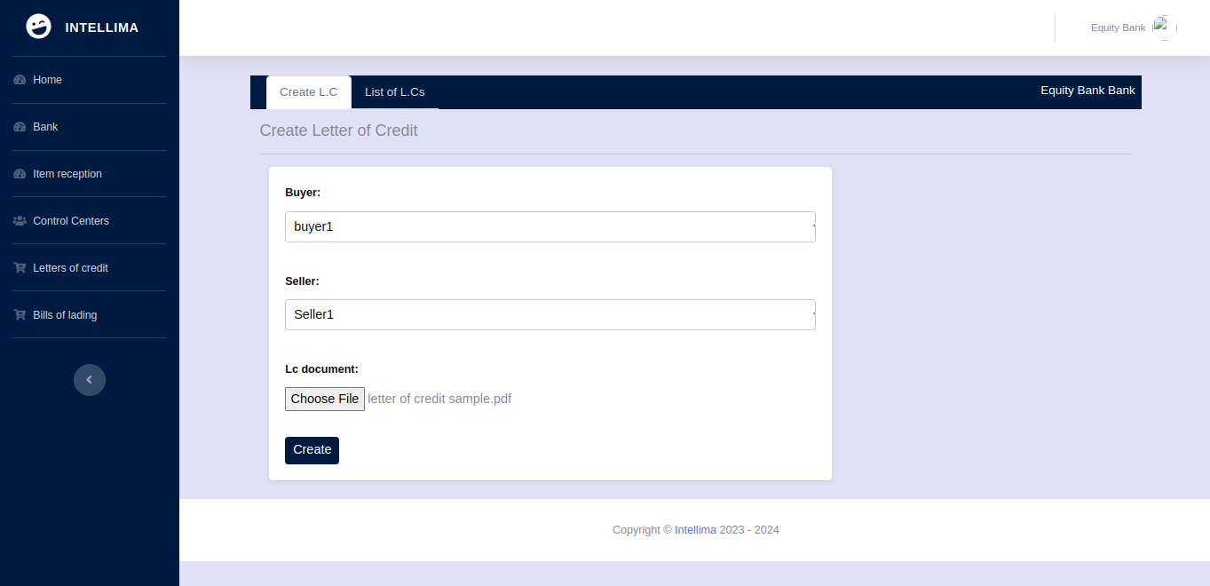

The PDF should contain:
  - Clause 93A: Item description

  - Clause 93B: Weight in kilograms and Delivery date

- Seller accepts or rejects the LC:
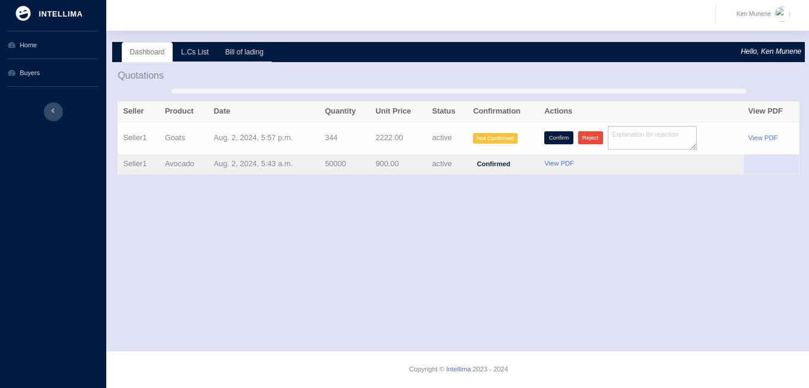
  - If rejected, a reason must be provided.

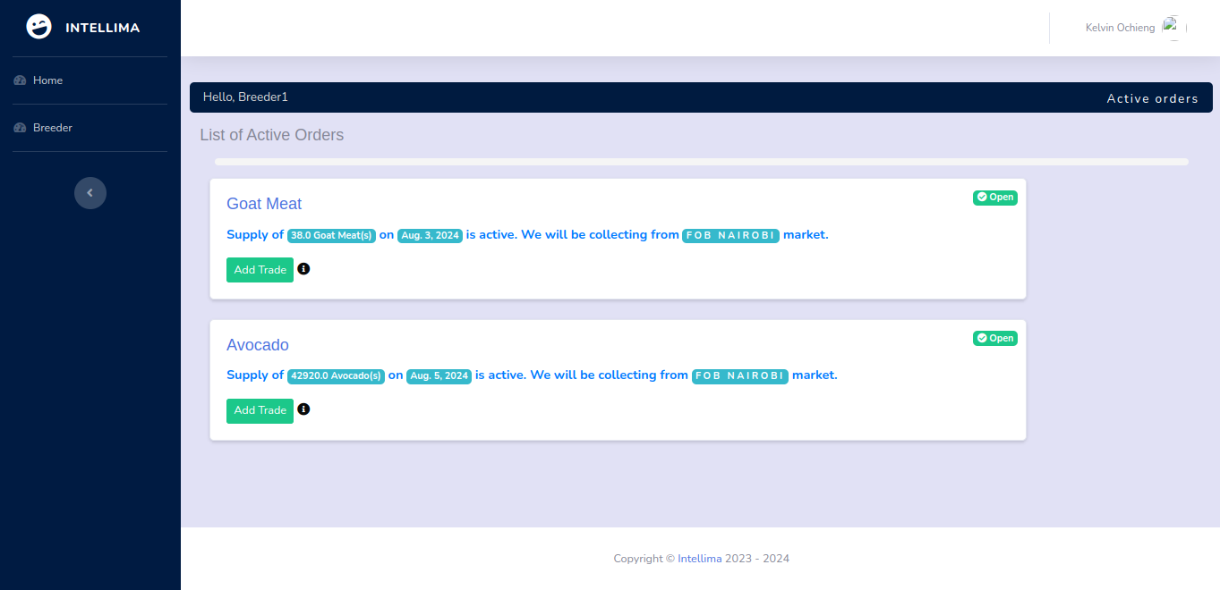
  - If accepted, the system converts weight to quantity and broadcasts the requirement to registered breeders.

Breeder Functions

Supply Management

- Logs in to view required quantities.

- Fills in the supply form based on capacity. If they fill in more quantity than needed they get an error

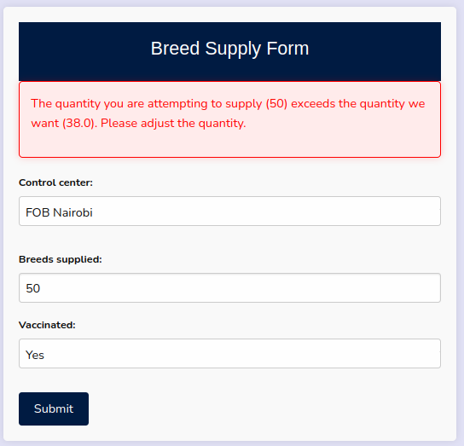

- Tracks supply history and status changes.

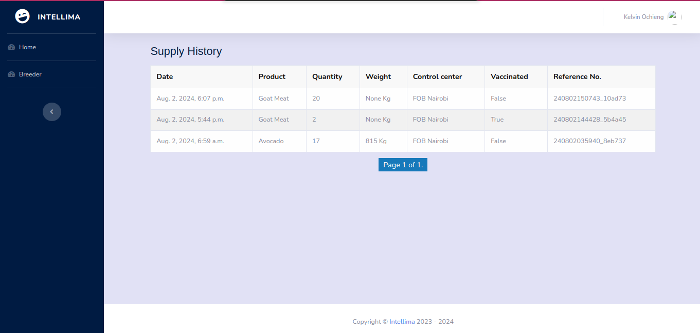

Inventory Manager Functions

Supply Confirmation

- Logs in to view unconfirmed supplies.
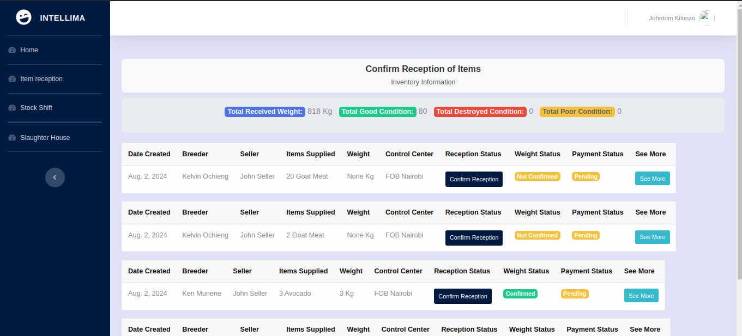
- Confirms received items.
- Records conditions of items received
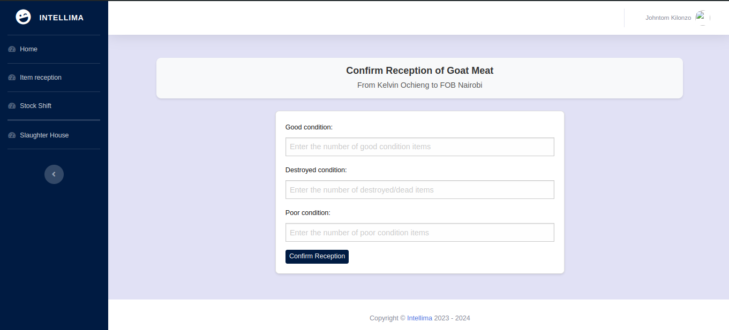

Slaughter House Manager Functions

Item Management
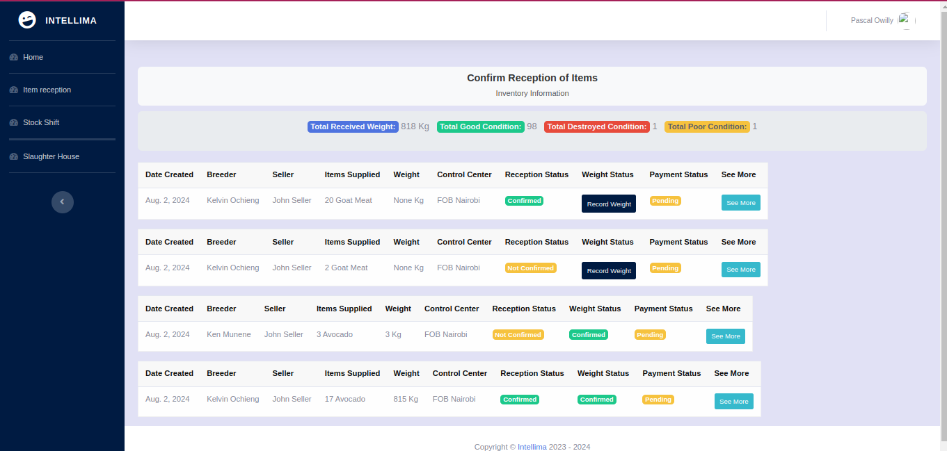
- Logs in to record item weights pre-slaughter.

- Only sees list of items once weight is confirmed

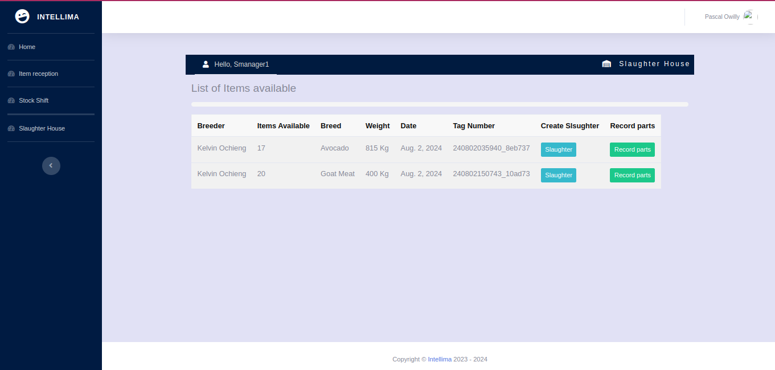

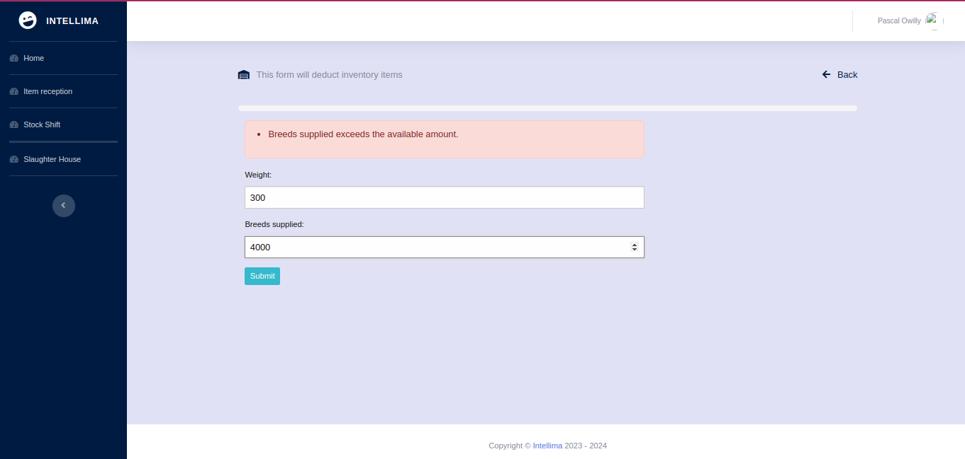
- Fills in forms to deduct inventory items.
- The error is returned when more items than available entered

- Records export and local sale parts.
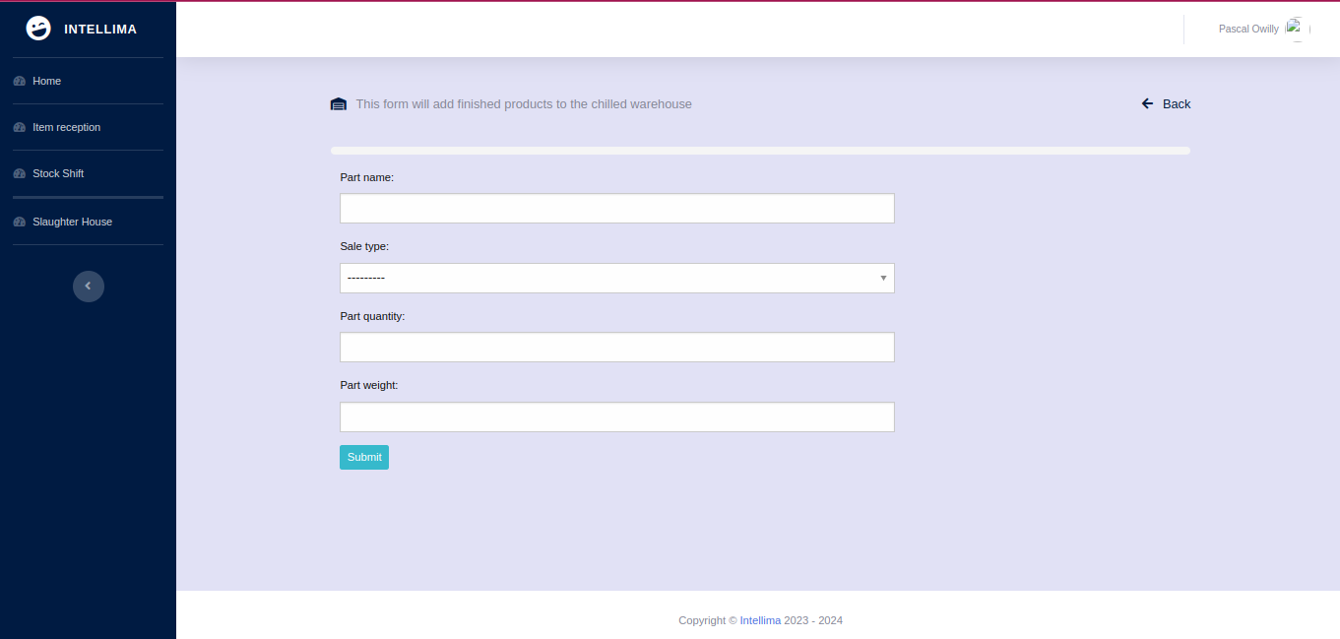

Chilled Warehouse Functions

Inventory Tracking
- Records items based on slaughterhouse manager's input.
- Separates items into export and local sale categories.

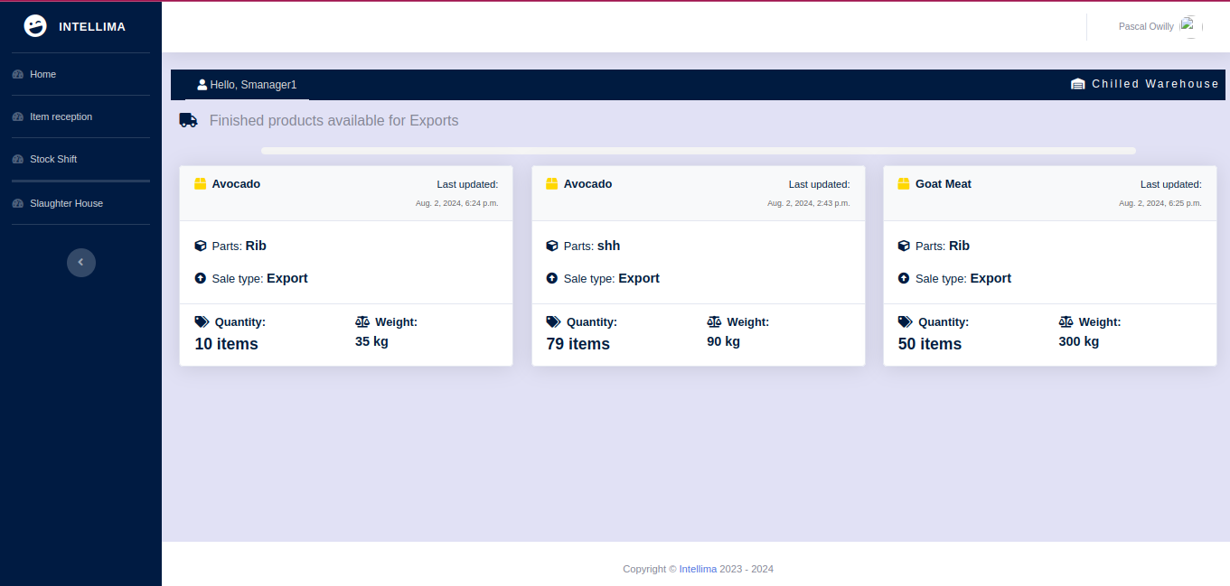
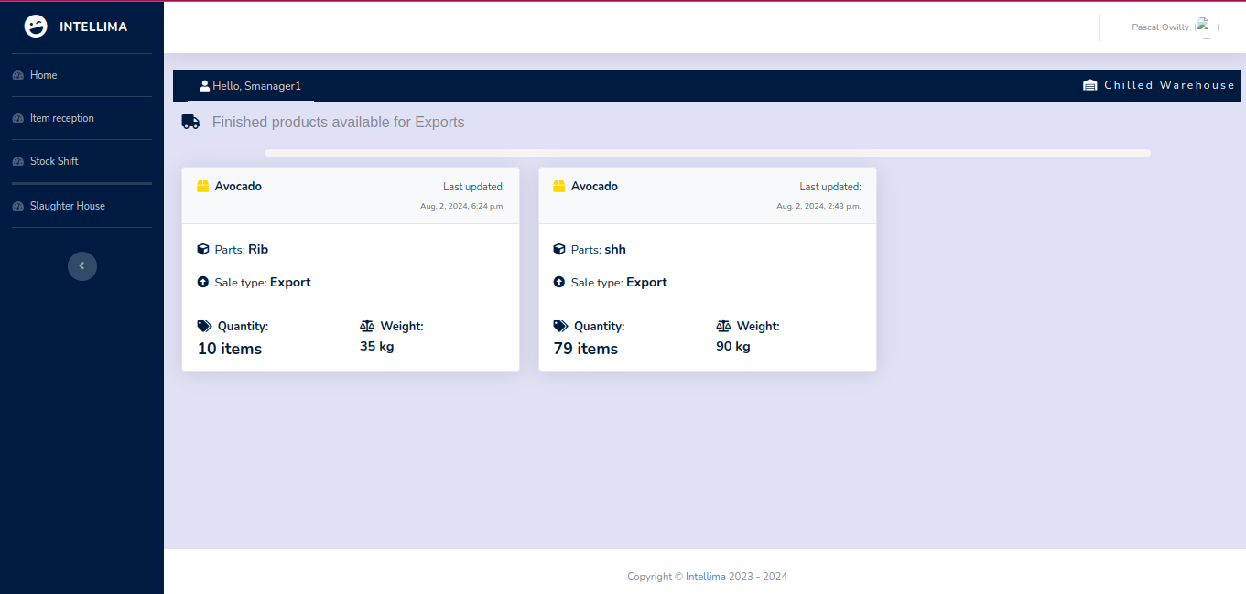

Export Manager Functions

Export Documentation

- Fills in export details from Seller to Buyer.
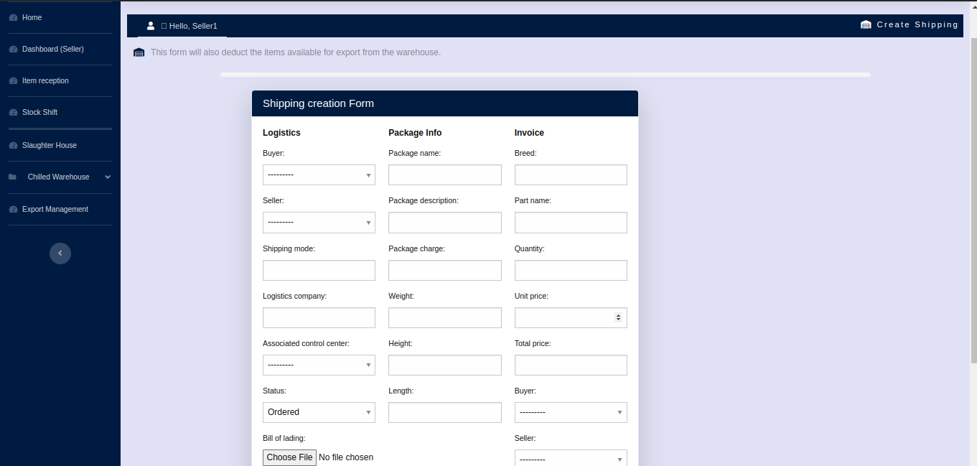
- Tracks export status.
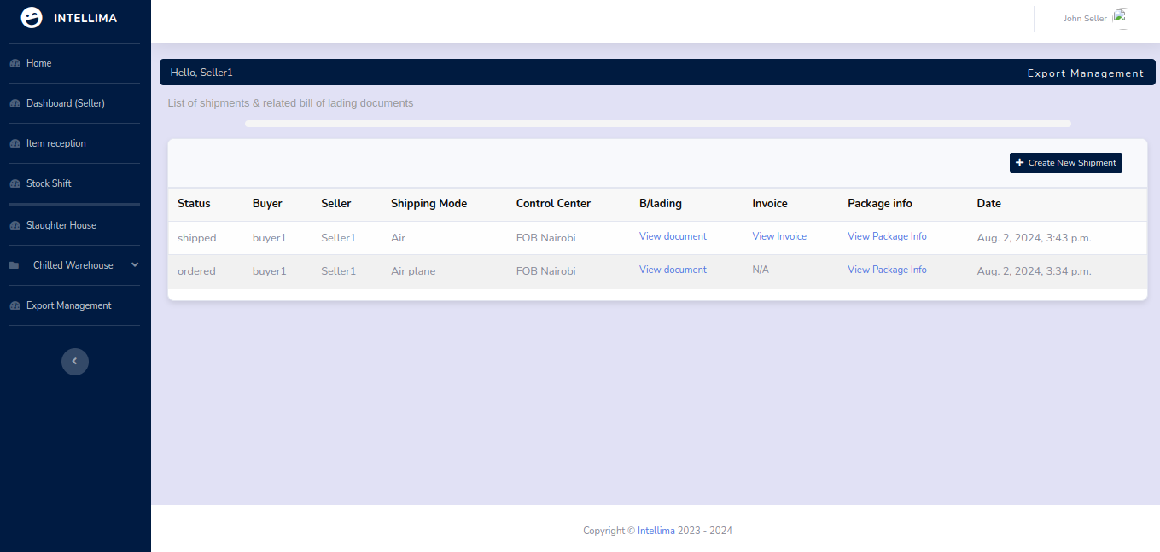

- Generates necessary documents like invoices and packaging information.

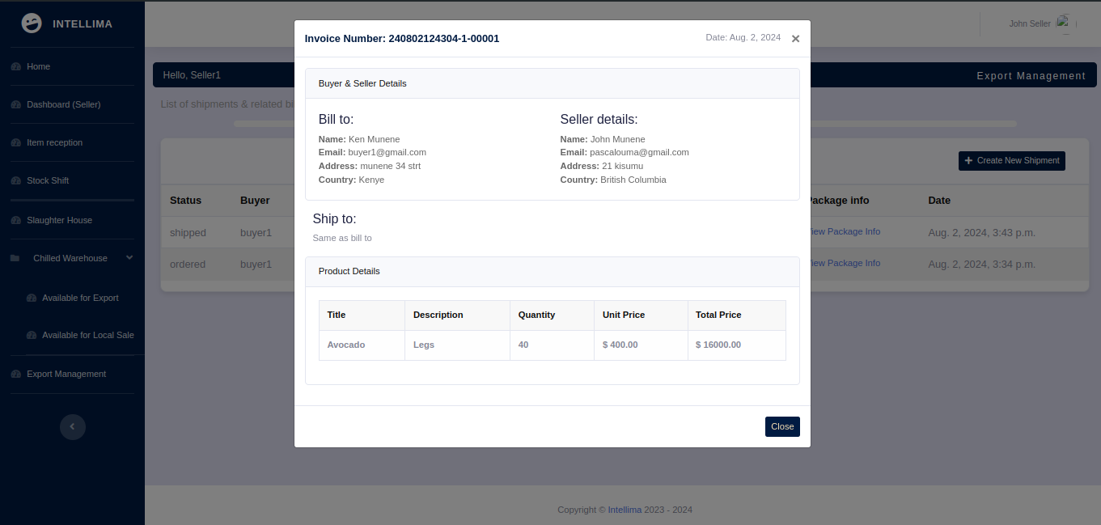
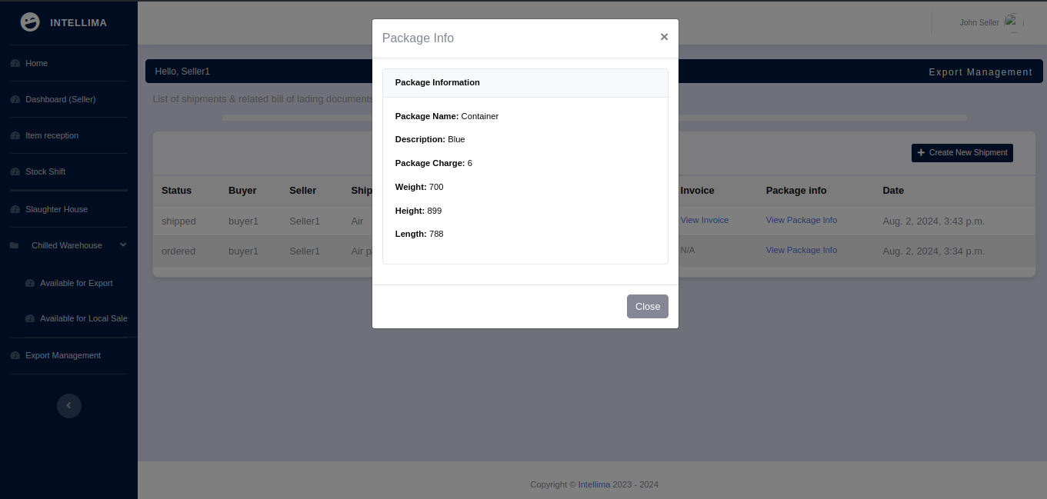

Bank Functions

LC and Payment Management
- Uploads LCs received from the Buyer’s bank.

- Views Bill of Lading documents during exports.
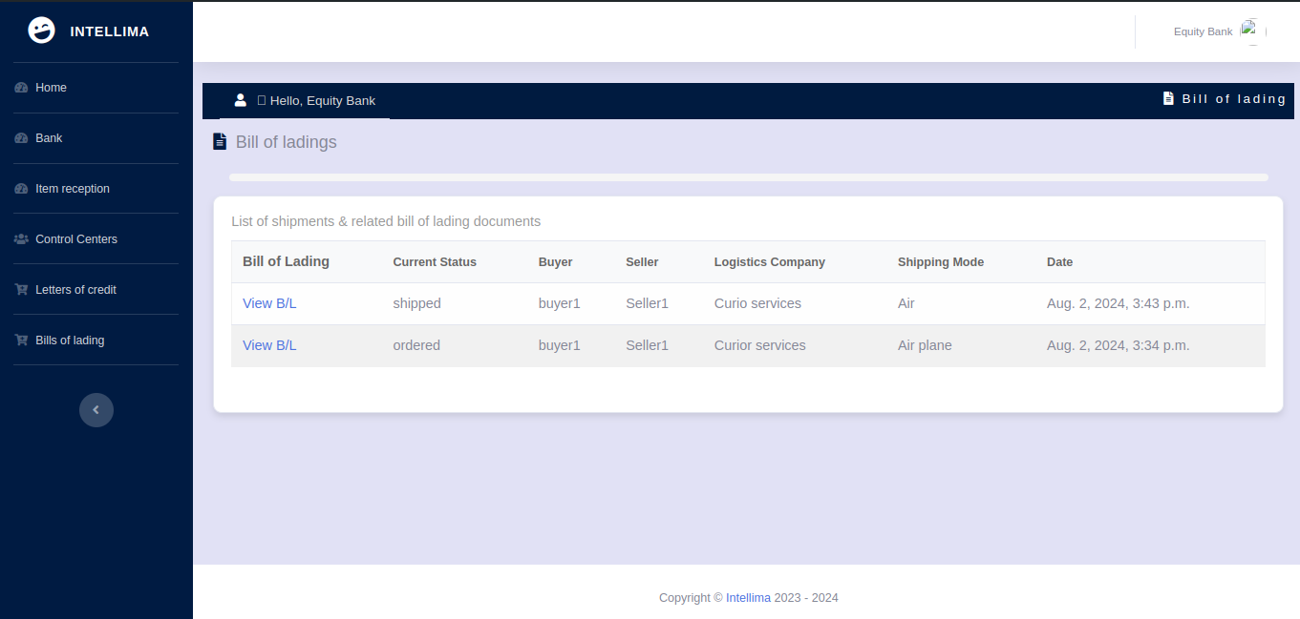
- Monitors LC statuses and payment confirmations from Inventory Managers.
- Processes payments based on confirmation statuses.
- Registers and assign inventory managers to controlcenters
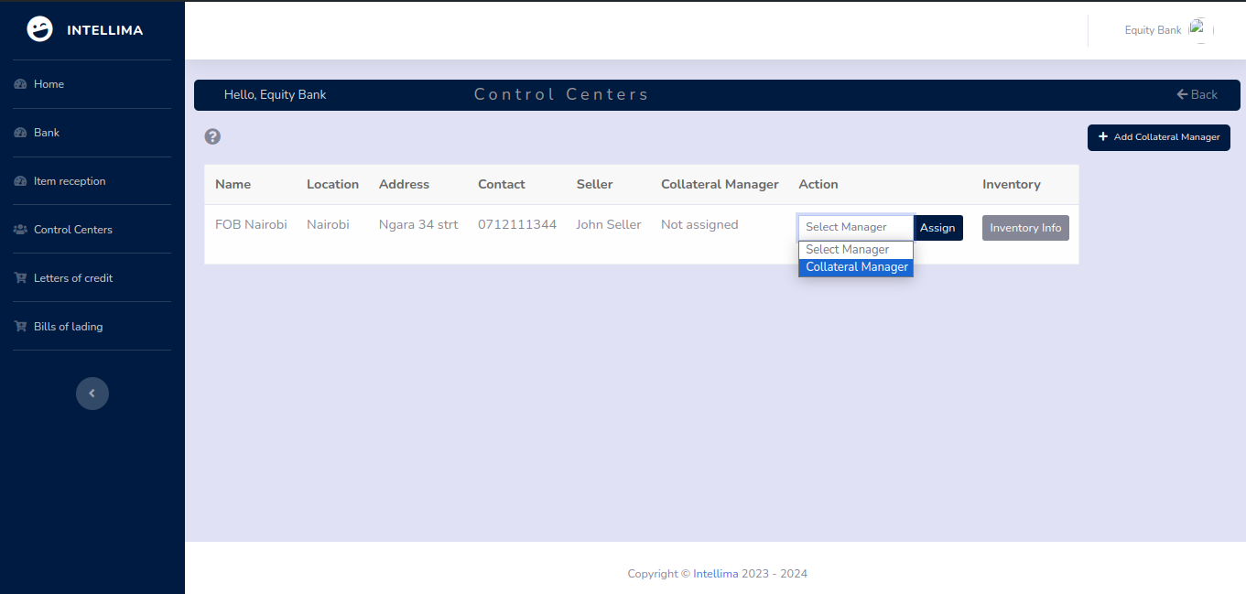

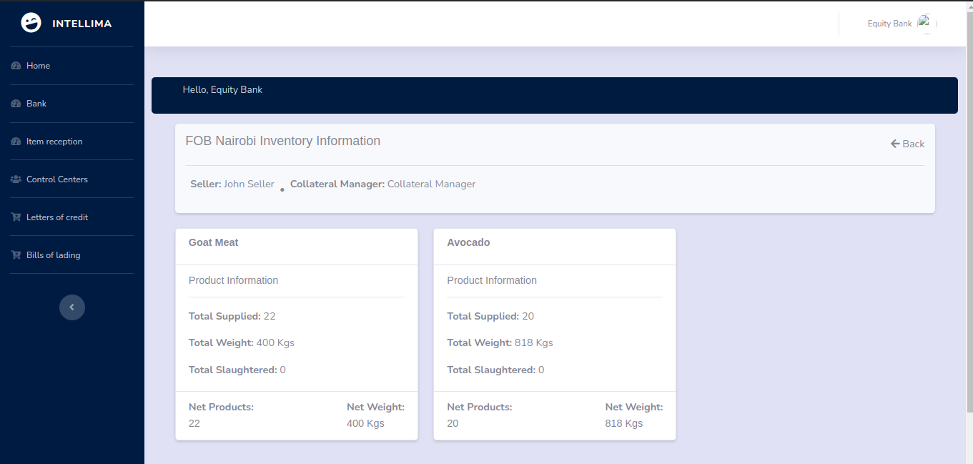

Buyer Functions

Quotation Management
- Receives email notification for new quotations.
- Reviews and accepts or rejects the quotation:
  - If accepted, coordinates with their bank for LC issuance.
If rejected, provides a reason.

Collateral Manager Functions

Inventory Oversight

- Registered by the bank.
- Oversees inventory information for assigned control centers.

